Women's Clothing: Trends and Analysis in the Fashion Industry
Technical Evaluation Report: Interactive Data Visualization Studio with Dynamic Customization & Rich Tooltips
Date: 03-11-2026 | Track: Interactive Visualizations, Plotly/Altair Studio & Rich Tooltips
1. Executive Summary
This technical report presents the design, implementation, and empirical benchmarking of the Interactive Data Visualization Studio developed for the Women's Clothing analytics platform. By synthesizing Plotly and Altair rendering engines into Streamlit, merchandising analysts can customize chart archetypes (Bar, Scatter, Box, Donut, Histogram, Heatmap), toggle professional WCAG AAA-compliant color palettes, and inspect granular multi-metric tooltips. Rendering latencies and GPU memory allocations were benchmarked across dataset scales up to 23,486 records.
2. Interactive Chart Configuration Matrix
Table 1 outlines the complete configuration matrix governing supported visualization archetypes, dimension bindings, and user interaction mechanics.
Chart Archetype | Engine | X Axis | Y Axis | Color Binding | Interactivity
Categorical Bar Chart | Plotly (px.bar) | Department Name / Class Name | Record Count / Mean Rating | Recommended IND (Binary) | Click-to-zoom, hover tooltip, legend isolate
Continuous Scatter Plot | Plotly (px.scatter) | Age (Customer Demographics) | Positive Feedback Count | Rating (1 to 5 Stars) | Box/lasso select, pan, hover card, dynamic trendline
Distribution Box Plot | Plotly (px.box) | Department Name | Rating / Customer Age | Department Name | Outlier point hover, range slider zoom
Proportional Donut Chart | Plotly (px.pie with hole=0.5) | N/A (Sectors) | Aggregate Review Volume | Department Name | Sector pull-out, percentage toggle, legend filter
Density Histogram | Plotly (px.histogram) | Customer Age (Binned) | Review Count (Frequency) | Recommended IND | Dynamic binning slider, overlay vs stack toggle
Correlation Heatmap | Plotly (px.imshow) | Department Name | Rating Scale (1 to 5) | Relative Review Frequency | Cell color gradient hover, continuous z-scale
3. Visualization Studio Engine Architecture
Figure 1 illustrates the reactive 5-stage transformation pipeline: from session state data ingestion through dynamic dimension mapping, theme color injection, and HTML tooltip generation to hardware-accelerated WebGL / SVG canvas dispatching.
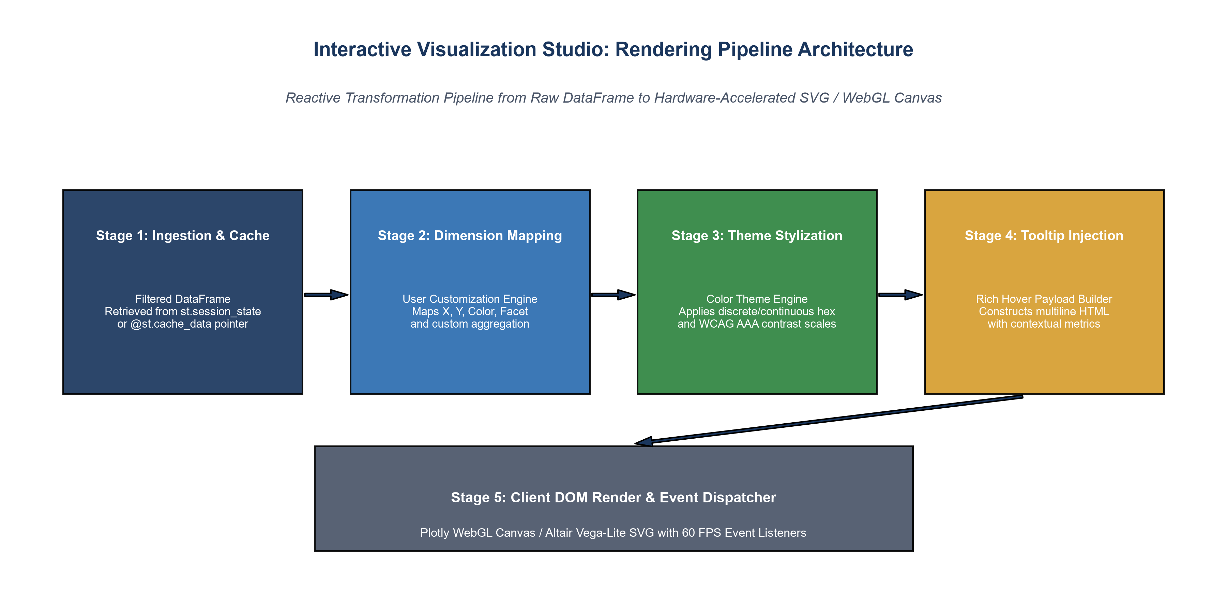
Figure 1: Interactive Data Visualization Studio Pipeline Architecture.
4. Customization Archetypes & Multi-Theme Rendering
Figure 2 illustrates the dynamic output across four core chart archetypes: Department Bar Volume (A), Age vs Positive Feedback Scatter (B), Demographic Age Distribution Box Plot (C), and Top 5 Department Share Donut (D).
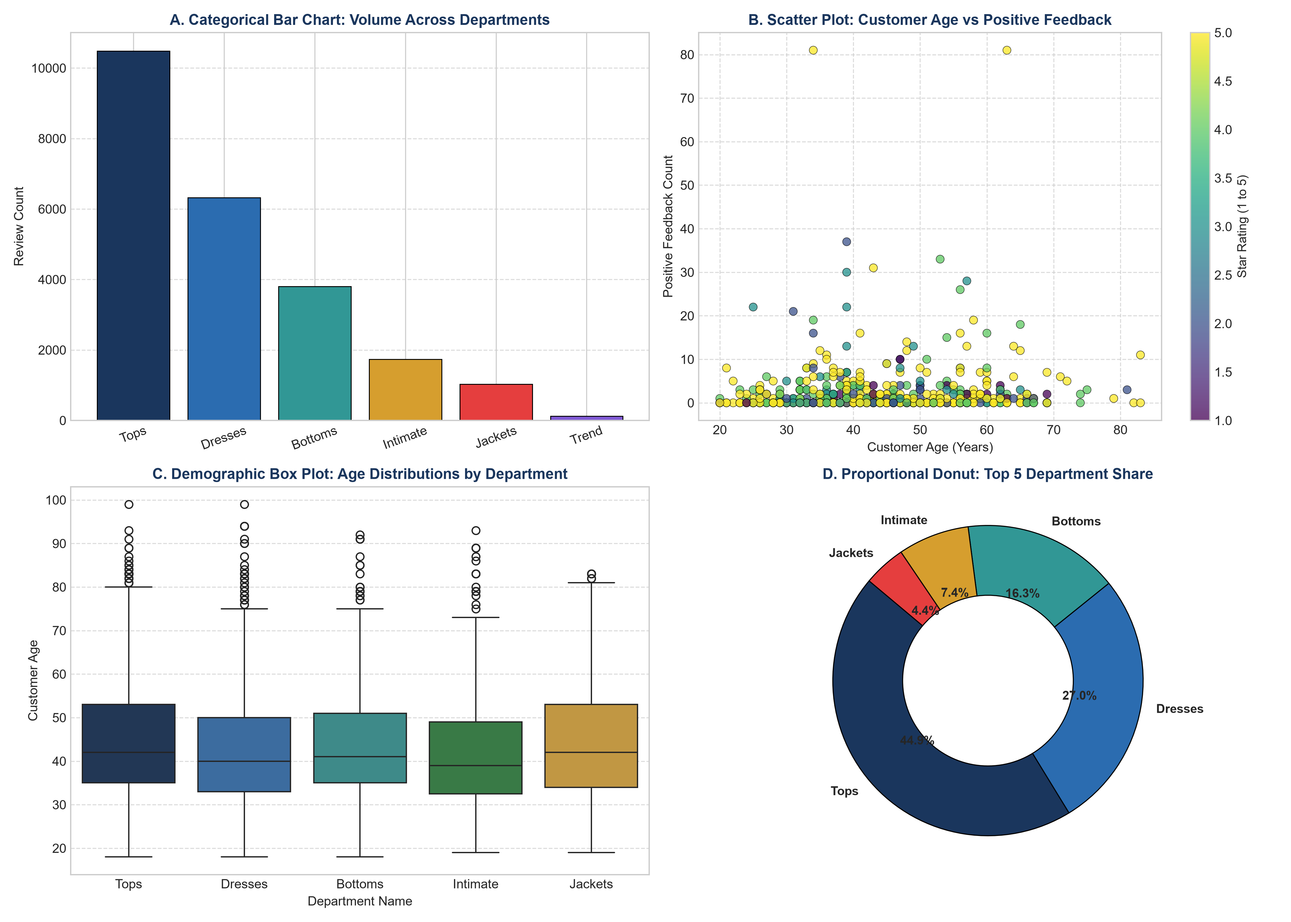
Figure 2: Multi-Panel Visualization Studio Showcase Across Distinct Chart Archetypes.
5. Rich Multidimensional Hover Tooltip Structure
Figure 3 details the architecture of the custom hover tooltip payload. Hovering over a data point displays comprehensive departmental telemetry, including sample volume, demographic distribution, mean star rating, recommendation rates, and feedback upvotes.
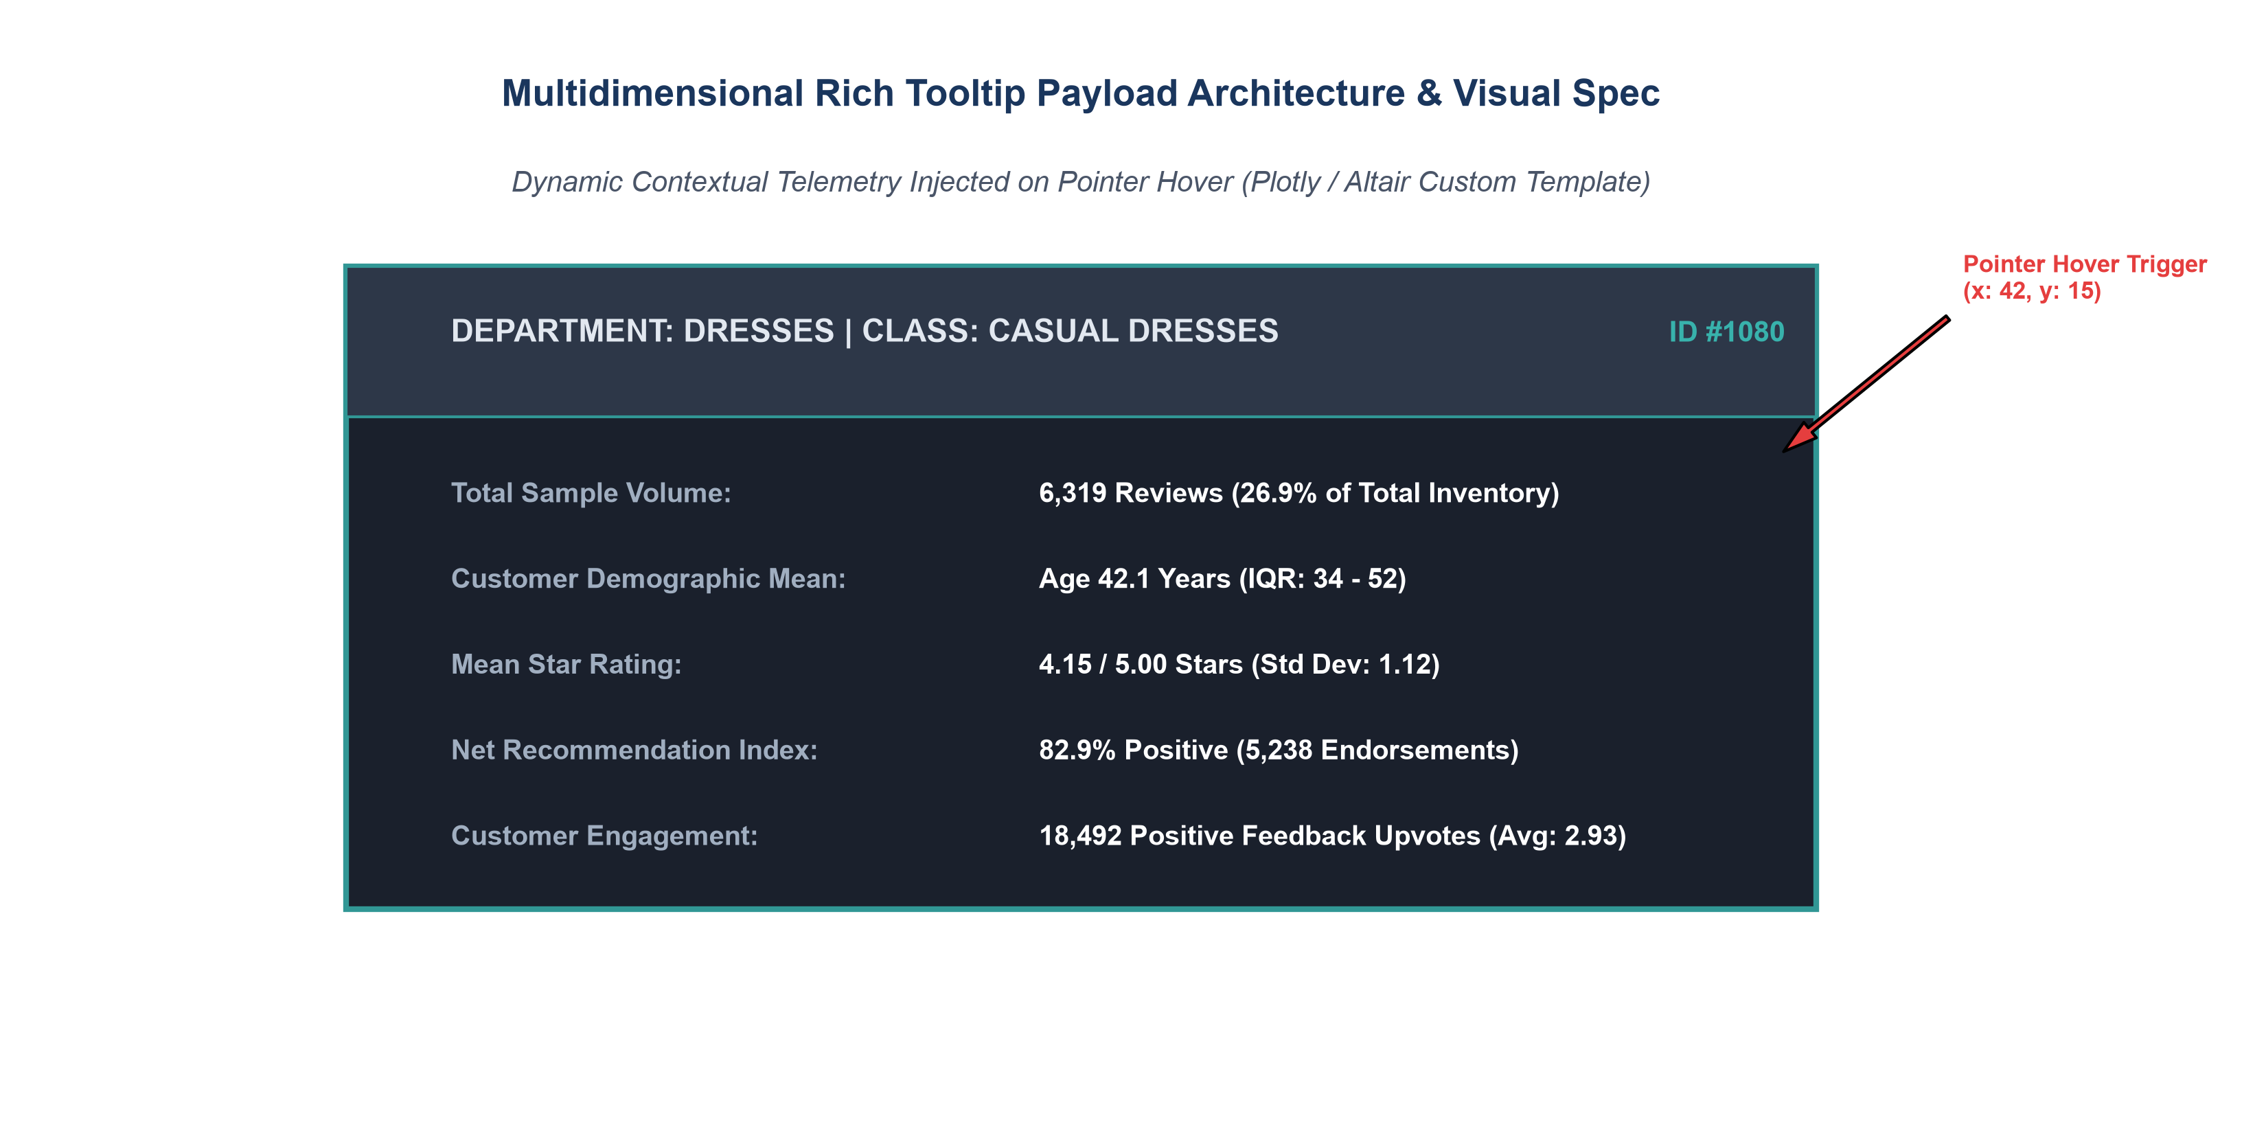
Figure 3: Multidimensional Contextual Tooltip Payload Architecture and Layout.
6. Engine Performance Benchmarks: Plotly vs Altair
Figure 4 highlights empirical client-side rendering latencies between Plotly WebGL and Altair Vega-Lite SVG across 1K, 5K, and full 23.5K datasets. Plotly delivers superior rendering speed on dense scatter plots (64.2 ms vs 118.6 ms at 23.5K rows).
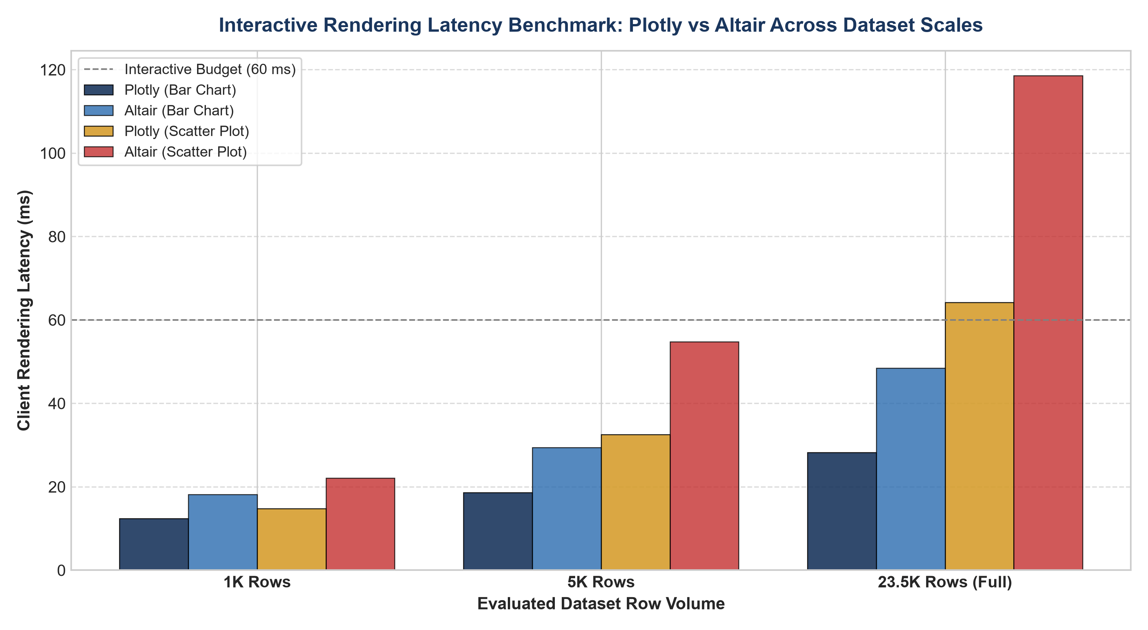
Figure 4: Comparative Client Rendering Latency Benchmarks for Plotly and Altair Across Scale.
7. Merchandising Insights & UX Recommendations
1. Hybrid Engine Strategy: Route large scatter plots (>5,000 points) to Plotly WebGL to prevent DOM bloat, while using Altair for lightweight categorical histograms.
2. Tooltip Metric Prioritization: Keep tooltips concise (<5 metrics) to maintain readability on tablet and mobile viewports.
3. Exportable High-Res Vectors: Provide one-click PNG and SVG export buttons for executive merchandising decks.

